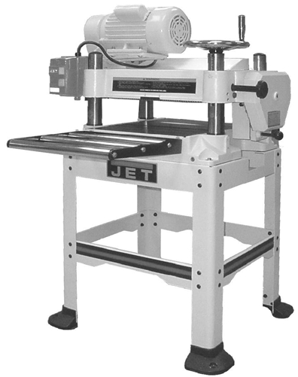


Operating Instructions and Parts Manual
16-inch Planer
Model JWP-16OS

WALTER MEIER (Manufacturing) Inc.
427 New Sanford Road
LaVergne, TN 37086 Part No. M-708531
Ph.: 800-274-6848 Revision B1 06/2013
www.waltermeier.com Copyright © 2013 Walter Meier (Manufacturing) Inc.
1
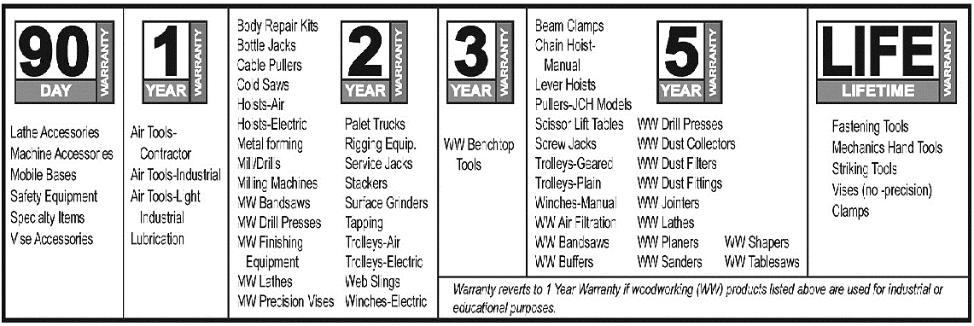

Warranty and Service
Walter Meier (Manufacturing) Inc., warrants every product it sells. If one of our tools needs service or repair, one of our Authorized Service Centers located throughout the United States can give you quick service. In most cases, any of these Walter Meier Authorized Service Centers can authorize warranty repair, assist you in obtaining parts, or perform routine maintenance and major repair on your JET® tools. For the name of an Authorized Service Center in your area call 1-800-274-6848.
MORE INFORMATION
Walter Meier is consistently adding new products to the line. For complete, up-to-date product information, check with your local Walter Meier distributor, or visit waltermeier.com.
WARRANTY
JET products carry a limited warranty which varies in duration based upon the product (MW = Metalworking, WW = Woodworking).

WHAT IS COVERED?
This warranty covers any defects in workmanship or materials subject to the exceptions stated below. Cutting tools, abrasives and other consumables are excluded from warranty coverage.
WHO IS COVERED?
This warranty covers only the initial purchaser of the product.
WHAT IS THE PERIOD OF COVERAGE?
The general JET warranty lasts for the time period specified in the product literature of each product.
WHAT IS NOT COVERED?
Five Year Warranties do not cover woodworking (WW) products used for commercial, industrial or educational
purposes. Woodworking products with Five Year Warranties that are used for commercial, industrial or education
purposes revert to a One Year Warranty. This warranty does not cover defects due directly or indirectly to misuse,
abuse, negligence or accidents, normal wear-and-tear, improper repair or alterations, or lack of maintenance.
HOW TO GET SERVICE
The product or part must be returned for examination, postage prepaid, to a location designated by us. For the name of the location nearest you, please call 1-800-274-6848.
You must provide proof of initial purchase date and an explanation of the complaint must accompany the merchandise. If our inspection discloses a defect, we will repair or replace the product, or refund the purchase price, at our option. We will return the repaired product or replacement at our expense unless it is determined by us that there is no defect, or that the defect resulted from causes not within the scope of our warranty in which case we will, at your direction, dispose of or return the product. In the event you choose to have the product returned, you will be responsible for the shipping and handling costs of the return.
HOW STATE LAW APPLIES
This warranty gives you specific legal rights; you may also have other rights which vary from state to state.
LIMITATIONS ON THIS WARRANTY
WALTER MEIER (MANUFACTURING) INC., LIMITS ALL IMPLIED WARRANTIES TO THE PERIOD OF THE LIMITED WARRANTY FOR EACH PRODUCT. EXCEPT AS STATED HEREIN, ANY IMPLIED WARRANTIES OR MERCHANTABILITY AND FITNESS ARE EXCLUDED. SOME STATES DO NOT ALLOW LIMITATIONS ON HOW LONG THE IMPLIED WARRANTY LASTS, SO THE ABOVE LIMITATION MAY NOT APPLY TO YOU.
WALTER MEIER SHALL IN NO EVENT BE LIABLE FOR DEATH, INJURIES TO PERSONS OR PROPERTY, OR
FOR INCIDENTAL, CONTINGENT, SPECIAL, OR CONSEQUENTIAL DAMAGES ARISING FROM THE USE OF
OUR PRODUCTS. SOME STATES DO NOT ALLOW THE EXCLUSION OR LIMITATION OF INCIDENTAL OR
CONSEQUENTIAL DAMAGES, SO THE ABOVE LIMITATION OR EXCLUSION MAY NOT APPLY TO YOU.
Walter Meier sells through distributors only. The specifications in Walter Meier catalogs are given as general information and are not binding. Members of Walter Meier reserve the right to effect at any time, without prior notice, those alterations to parts, fittings, and accessory equipment which they may deem necessary for any reason whatsoever. JET® branded products are not sold in Canada by Walter Meier.
2

Table of Contents
Table of Contents 3
Warning 4
Safety Decals 5
Features of the JWP-16OS Planer 6
Specifications 6
Receiving 7
Parts Inventory 7
Assembly 8
Stand Assembly 8
Planer Unit Placement 8
Starter Box 9
Handwheel 9
Extension Rollers 9
Dust Collection Hood 9
Electrical Connections 10
Extension Cords 10
Adjustments 10
Overview 10
Control and Adjustments 10
Pulleys and Belts 11
Pulley Alignment 11
Belt Tension 11
Table Rollers 12
Extension Roller 12
Depth of Cut Adjustment 13
Knife Adjustment 13
Removing and Replacing Knives 15
Table Adjustment 15
Checking Work Table Parallel to Cutterhead 16
Adjusting Work Table Parallel to Cutterhead (Fine Adjustment) 16
Adjusting Work Table Parallel to Cutterhead (Major Adjustment) 16
Transmitting Rollers 17
Infeed & Outfeed Roller Spring Tension Adjustment 17
Anti-Kickback 18
Checking and Adjusting the Feed Roller Height 18
Gearbox 19
Operation 19
Table Locks 20
Power Feed 20
Handwheel 20
Depth Limiter 20
Initial Startup 21
Maintenance 21
General 21
Sharpening Knives 21
Lubrication 23
Optional Accessories 24
Troubleshooting 25
Performance Troubleshooting 25
Mechanical Troubleshooting 26
Parts List for the JWP-16OS Planer 27
Head Assembly 27
Head Assembly Parts List 28
Base Assembly 30
Base Assembly Parts List 30
Gear Box Assembly 32
Gear Box Assembly Parts List 33
Stand Assembly 34
Stand Assembly Parts List 34
Electrical Schematic for JWP-16OS Planer 35
3



W arning
1. Read the manual. Always read the owner’s manual carefully before attempting to use the machine.
Know the limitations and hazards associated with the use of this planer.
2. Installation. If mounting machine to the floor, use high quality anchor bolts through the mounting
holes on the base. If using a mobile base, be sure to lock the wheels.
3. Eye protection. Always wear approved safety goggles, glasses, or a face shield when operating this
machine. NOTE: Common eyeglasses are only impact resistant; they are not safety glasses. Also use face or dust mask if the cutting operation is dusty.
4. Dress code. Do not wear loose clothing, neckties, jewelry, or gloves that can get caught in moving
parts. Confine long hair. Keep sleeves above the elbow.
5. Placement. Place machine so that potential kickback area is not in line with aisles, doorways, wash
stations or other work areas. Do not use machine in a damp or wet location, or expose to rain. Keep work area well lighted.
6. Electrical grounding. Your machine must be electrically grounded. If a cord and plug are used,
make certain the grounding lug connects to a suitable ground. Follow the grounding procedure indicated by the National Electrical Code.
7. Guards. Be sure machine guards are in place and in good working order. Do not operate while gear
cover is open. If a guard must be removed for adjustments or maintenance, it should be reinstalled immediately upon completion of the procedure and before operating the machine.
8. Housekeeping. Before turning on machine, remove all extra equipment such as keys, wrenches,
scrap, stock, and cleaning rags from the machine. Keep the area around machine clean and free of scrap material and sawdust to minimize the danger of slipping.
9. Power off. Make sure the machine is either unplugged or electrically disconnected and locked out
when performing maintenance or service work. Also, make sure switch is in OFF position before plugging in power cord. Never leave the machine running unattended. Do not leave machine until it comes to a complete stop.
10. Cutterhead. Keep knives sharp and free of all rust and pitch. Make sure gib screws are tightened
securely.
11. Work piece. Check material for loose knots, nails and other defects that can damage knives and
pose a safety hazard for the operator.
12. Keep hands away from feed rollers and cutterhead while operating.
13. Use the proper extension cord. Make sure your extension cord is in good condition. When using an
extension cord, be sure to use one heavy enough to carry the current your product will draw. An
undersize cord will cause a drop in line voltage resulting in loss of power and overheating. For runs
up to 25 feet, use an 18 AWG or larger gauge cord.
14. Do not operate this machine while under the influence of drugs, alcohol or any medication.
15. If you are not thoroughly familiar with the operation of wood planers, obtain advice from your
supervisor, instructor or other qualified person.
16. Health hazards. Some dust created by power sanding, sawing, grinding, drilling and other
construction activities contains chemicals known to cause cancer, birth defects or other reproductive harm. Some examples of these chemicals are:
• Lead from lead-based paint.
• Crystalline silica from bricks and cement and other masonry products.
• Arsenic and chromium from chemically treated lumber.
Your risk from these exposures varies, depending on how often you do this type of work. To reduce
your exposure to these chemicals, work in a well-ventilated area, and work with approved safety
equipment, such as those dust masks that are specifically designed to filter out microscopic particles.
4



Familiarize yourself with the following safety notices used in this manual.

This means that if precautions are not heeded, it may result in serious injury or
possibly even death.

This means that if precautions are not heeded, it may result in minor or moderate
injury and/or possible machine damage.

Safety Decals
Familiarize yourself with the location and content of these decals on your planer.

!

1. Read instruction manual before operating machine.
2. Do not operate without all guards properly installed.
3. Remove or fasten loose articles of clothing such as neckties, etc.
Contain long hair.
4. Remove jewelry such as finger rings, watches, bracelets, etc.
5. Use approved safety glasses and/or face shield to protect eyes, and
use other personal safety equipment as required. Do not wear
gloves.

6. Disconnect machine from power source before making any
adjustments or cleaning chips away from machine.
7. Keep the floor around machine clean and free from scraps,
sawdust, oil and grease to minimize the danger of slipping.
8. Do not operate this machine while under the influence of alcohol
or drugs.
9. Failure to comply with these warnings may result in serious
personal injury.

DO NOT REMOVE OR OBSCURE THIS LABEL

5

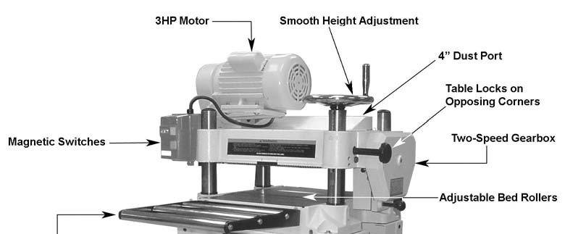
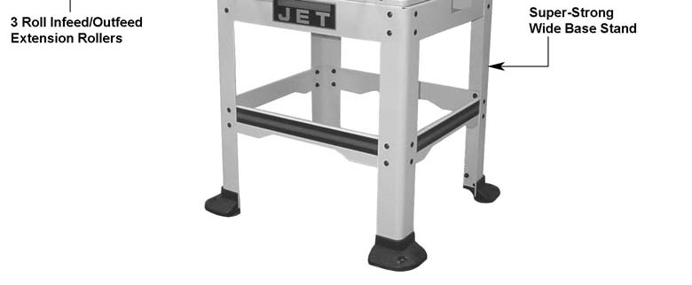

Features of the JWP-16OS Planer

Specifications
Model Number JWP-16OS
Stock Number 708531
Maximum Planing (W/in.) 16
Maximum Planing Thickness (T/in.) 6
Maximum Depth of Cut (in.) 3/16
Maximum Full Width Depth of Cut (in.) 1/8
Maximum Opening (in.) 6-3/8 x 16
Minimum Planing Length (in.) 8
Knives 3
Planer Blade Size (L x W x T/in.) 16-1/8 x 1 x 1/8
Cutterhead Speed (RPM) 4,500
Cuts per Minute 13,500
Cutterhead Diameter (in.) 2-7/8
Feed Rate (FPM) 16 & 20
Dust Port Diameter (in.) 4
Overall Dimensions (L x W x H/in.) 48 x 32 x 51
Footprint (LxW/in) 27-3/4 x 25-1/8
Motor 3HP, 1Ph, 230V
Net Weight (approx. lbs.) 430

The specifications in this manual are given as general information and are not binding. Walter Meier (Manufacturing) Inc., reserves the right to effect, at any time and without prior notice, alterations to parts, fittings, and accessory equipment deemed necessary for any reason whatsoever.

6

Receiving
Carefully unpack the planer and any loose items from the wood crate and inspect for damage. Any damage should be reported immediately to your distributor and shipping agent. Before proceeding further, read your manual thoroughly to familiarize yourself with proper assembly, maintenance and safety procedures.
Remove the protective coating from the table, bed rolls, feed rolls, cutterhead and loose items packed with the machine, including lifting handles and motor pulley. This coating may be removed with a soft cloth moistened with Kerosene. Do not use acetone, gasoline or lacquer thinner for this purpose. Do not use solvents on plastic parts.
Parts Inventory
Parts requiring assembly:
1 Planer Unit
1 4" Dust Hood
2 In/Outfeed Extension Roller Assembly
1 Handwheel

Cast Foot Assembly:
4 Cast Feet
1 Hardware Bag, consisting of:
8 Socket Head Flat Screws
8 Flat Washers
8 Hex Nuts

Stand Assembly:
4 Stand Legs
2 Stand Braces - long
2 Stand Braces - short
2 Stand Top - front & rear
1 Stand Top - left
1 Stand Top - right
1 Hardware Bag, consisting of:
32 Carriage Bolts
32 Flat Washers
32 Hex Nuts

Accessory Package:
1 Handle
2 Knife Gauges
1 Knife Setting Gauge Bar
4 E-Rings for Knife Setting Gauge
4 Hex Wrenches - 3, 4, 5, 6mm
2 Open Wrenches - 8/10mm, 12/14mm

Hardware Bag for Handwheel:
1 M10 Hex Nut
1 M10 Flat Washer
1 Direction Label

Hardware Bag for Infeed/Outfeed Extension Rollers
6 M8 x 20 Hex Head Screws
6 M8 x 12 Set Screws
6 M8 Flat Washers

Hardware Bag for Dust Hood:
6 M6 x 12 Hex Head Screws

Hardware Bag for Base to Stand:
4 M8 x 30 Hex Head Screws
4 M8 Hex Nuts
8 M8 Flat Washers

7



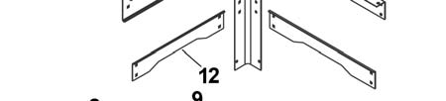
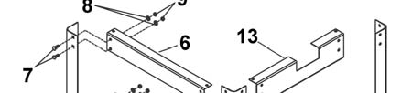
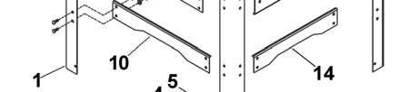


Assembly
Most of the JWP-16OS Planer has been assembled at the factory. However some parts must be assembled after delivery.

Use care when cleaning the cutterhead; the knives are very sharp.
Stand Assembly
Refer to Figure 1.
1. Cast Foot Assembly - Using parts from the
cast foot assembly hardware bag, mount
casting (2) to leg (1) by inserting two socket head flat screws (3) through the casting (2) and leg (1). Place a flat washer (4) and hex nut (5) on the screw and tighten.
Repeat for remaining three legs.
2. Stand Top (front) - The front and rear top
stands (braces) are identical except for the
JET logo on the front piece.
Mount one end of the stand top (6) to a leg
(1) and fasten using two each carriage bolts
(7), flat washers (8) and hex nuts (9).
Note: Do not over tighten at this time. This will be the final step in the assembly.
3. Fasten a second leg to the other end of the
stand top, repeating the step above.
4. Take one long stand brace (10) and with
(4 ea) bolts, washers, and hex nuts fasten to
the legs of the assembly just completed in the steps 2 and 3. Fasten to the mounting holes in the middle of each leg.
5. Set this assembly aside for now.
6. Stand Top (rear) - Repeat steps 2-4 using
parts still remaining.
7. Take the left stand top (11)
Note: The right stand top (13) has a cutout and will be used later.
Secure it to left side of the left legs (top mounting holes) of the front and rear assemblies previously constructed (the JET logo is the front) using 4 ea carriage bolts, flat washers and nuts.
8. Take one short stand brace (12) and secure
to the left legs of the front and rear assembly
with (4 ea) carriage bolts, washers and nuts.
9. Take the right stand top (13) - this piece has
the cutout - and secure it to the front and
rear legs (top mounting holes) on the right

side of the assembly using 4 ea carriage bolts, washers and nuts.
10. Secure the remaining short stand brace (14)
to the front and rear legs (middle mounting
holes) on the right side of the stand with (4 ea) carriage bolts, washers and nuts.
11. Make sure that the stand is symmetrical and
level. Adjust if necessary and securely
tighten all bolts.
12. Before mounting the planer on the stand,
locate the stand on a solid, level foundation
to ensure best planing performance and
anchor to the floor with good quality lag
screws.

Figure 1
Planer Unit Placement
There are four lifting handles (Fig. 2) on the machine. The handles can be pulled out (A, Fig. 2) for use when the planer is to be lifted and moved and slides into the body casting (B, Fig. 2) when not needed.
If a sling or forklift is used to lift the machine, be sure to lift by the handles only. Make sure machine is kept in level position while lifting.
Set the machine on the stand that was
assembled in the previous section, then secure
the base to the stand using parts provided in the
base to stand hardware bag, consisting of 4 ea
M8 x 30 hex cap screws, 4 ea M8 hex nuts, and
8 ea M8 flat washers.

8

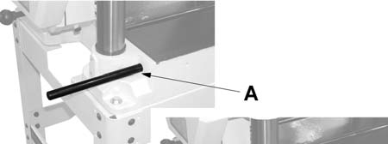
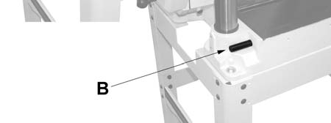
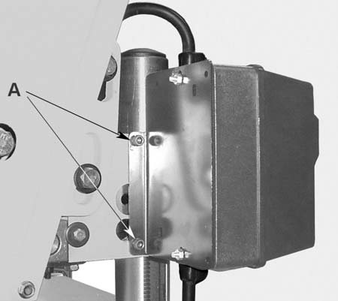
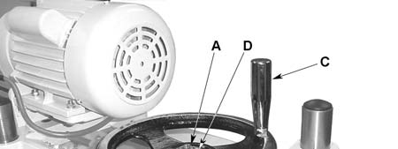
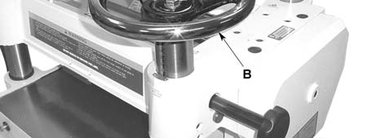
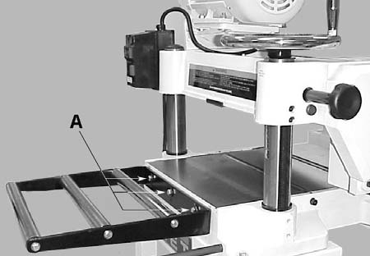

5. Mount the handle (C, Fig. 4) for the
handwheel in the threaded hole in the
handwheel, and tighten with a wrench
placed over the flat (12mm) on the handle.

Figure 2
Starter Box
The switch assembly (starter box and bracket) is

pre-assembled at the factory and simply needs
to be mounted to the head casting on the left
side of the machine with two socket head cap
screws (A, Fig. 3) already in place the head
casting.

Figure 3
Handwheel
1. Remove the tape holding the key in the
shaft.
2. Place the handwheel (B, Fig. 4) onto the
shaft; making sure it is oriented so the
handwheel slips over the key.
3. Remove the adhesive backing from the
direction label supplied with the hardware
bag for the handwheel. Place the label onto
the shaft and press it on the handwheel (D,
Fig. 4).
4. Place flat washer and hex nut on shaft and
tighten with wrench.
Figure 4
Extension Rollers
Mount two extension rollers to the table using the provided 6 ea M8 x 20 hex cap screws (12mm), 6 ea M8 flat washers, and 6 ea M8 x 12 set screws (A, Fig. 5). The rollers should be adjusted before operating the planer (this will be explained later in the Adjustment section).

Figure 5
Dust Collection Hood
Referring to Figure 6:
The dust collection hood (A) comes standard with the model JWP-16OS planer, and helps maintain a clean and safe work area. It is assembled to the planer (B) with six hex head screws (C) as shown.

9










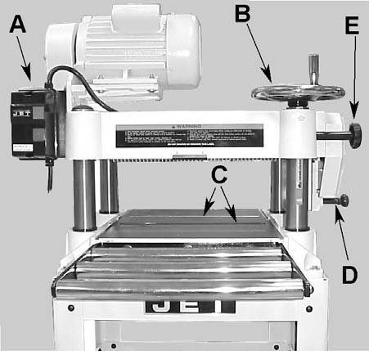

Length of Cord

Rated
Amps

25 ft 50ft 100ft

0-6 18 16 16

7-10 18 16 14

11-12 16 16 14

13-16 14 12 12

17-20 12 12 10

Figure 6
Electrical Connections

Electrical connections must be made by a

21-30 10 10

Figure 7
Adjustments
Overview
Not
recommended

qualified electrician in compliance with all relevant codes. The machine must be properly grounded to help prevent electrical shock and possible fatal injury.
A power plug is not provided with the JWP-16OS planer. You may either connect a plug or "hard-wire" the machine directly to your electrical panel provided there is a disconnect near the machine. Consult the wiring diagrams at the end of this manual.
This machine must be grounded. Grounding provides a path of least resistance to help divert current away from the operator in case of electrical malfunction.
Make sure the voltage of your power supply matches the specifications on the motor plate of the machine.
Extension Cords
The use of an extension cord is not
recommended for this machine, but if one is
necessary make sure the cord rating is suitable
for the amperage listed on the machine's motor
plate. An undersized cord will cause a drop in
line voltage resulting in loss of power and
overheating.
The chart in Figure 7 shows the correct size cord to use based on cord length and motor plate amp rating. If in doubt, use the next heavier gauge. The smaller the gauge numbers the heavier the cord.
Many parts are factory adjusted. The operator should be familiar with the following procedures to gain a better understanding of the JWP-16OS Planer's construction and operation.
Control and Adjustments
Refer to Figure 8 for general control and adjustment locations for the JWP-16OS Planer and are also listed below.
A - Switch
B - Handwheel
C - Table Rollers
D - Feed Rate Change Knob
E - Two Table Lock Knobs on Opposing
Corners

Figure 8

10

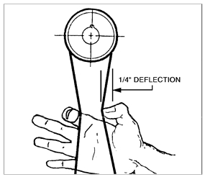
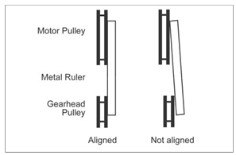
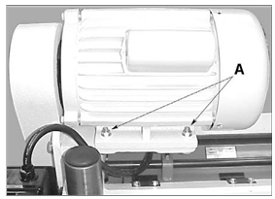
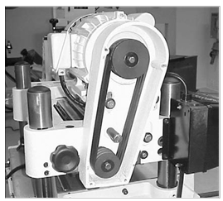

Pulleys and Belts
The belt and pulley assembly are on the left side
of the planer. To inspect for pulley alignment
and correct belt tension, remove the four hex
head screws (10mm) holding the cover in place.
Figure 9 shows the assembly with the cover
removed.
Pulley Alignment
1. Place the edge of a metal ruler so it rests
perpendicular against the flat sides of the
motor and cutterhead pulleys (Fig. 11).

If the pulleys lie in straight plane (Fig. 11) they are aligned.

Figure 9
If the pulleys need to be aligned:
2. Loosen four bolts (12mm) on the motor
mounting base plate (Fig. 10), which will
allow the motor to move from side-to-side.

Figure 10
3. Adjust the motor until the pulleys are in the
aligned position as shown in Figure 11.
4. Re-tighten all bolts.
Figure 11
Belt Tension
Check the belt tension by squeezing the belts
together in the middle (between the motor and
cutterhead pulleys as shown in Fig. 12) with
moderate pressure. Proper tension is indicated
when there is approximately 1/4” deflection.

Figure 12
To adjust the belt tension:
1. Loosen the two 17mm bolts (A, Fig. 13) that
hold the motor/pulley assembly to the
planer.
2. Using a lever, raise the motor to increase
the belt tension.
Note: Belts will rarely be too tight. Adjustment typically requires belt tightening.
3. Tighten the bolts and check the belt tension
again.
4. Verify that the pulleys are still in alignment.

11

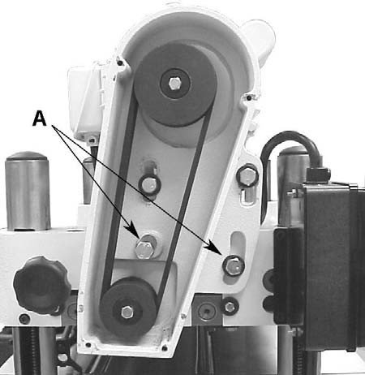
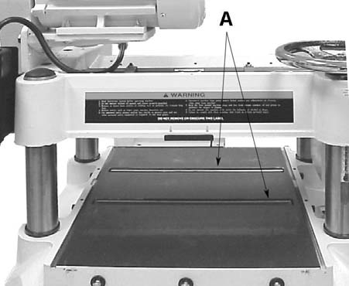
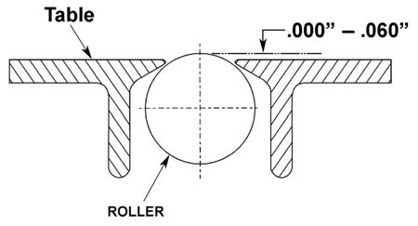
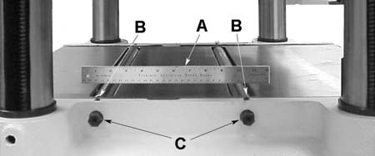

Figure 15
To adjust the rollers (refer to Figure 16):
1. Disconnect machine from power source.
2. Select a side (left or right) and lay a steel
ruler or straightedge across both rollers (A).
3. On the side selected, loosen the screws (B)
with an Allen wrench, and turn the eccentric

Figure 13
Table Rollers
Two table rollers (A, Fig. 14) ease stock
movement as it is fed through the planer. The
height of the rollers is dependent on the type of
wood being planed. When planing rough stock,
set the rollers slightly high to keep the lumber
from dragging along the table. Smooth lumber
should be planed with the rollers set just above
the plane of the table.

Figure 14
The two table rollers are preset at the factory at
0.004" above the table. The height adjustment range is from 0 to 0.06" (Fig. 15).
shafts (C) (12mm hex head adjustment) to raise or lower the rollers to the desired level. Use a feeler gauge to measure the clearance between the table and the bottom of the straightedge.
4. When the proper height is achieved, tighten
screws (B).
Adjust the rollers from the opposite side of the table in the same manner.
Important: Measure in several places. This measurement must be consistent across the entire table.

Figure 16
Extension Roller
Referring to Figure 17:
Place a straight edge (A) over the extension
roller (B) and the table to make sure the
extension roller and table are at the same
height.

12

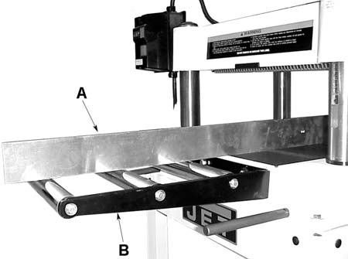
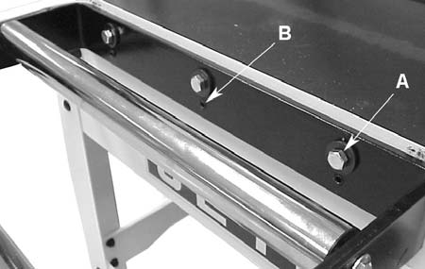
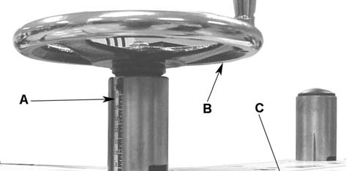
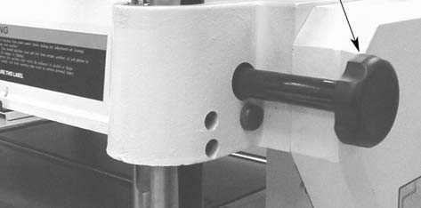
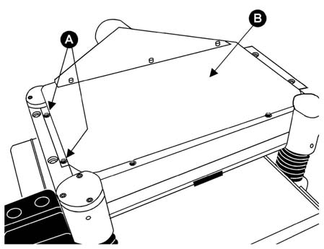

Note: The JWP-16OS Planer has two lock
knobs; one is located by the handwheel
(C, Fig. 19). The other is located on the opposite
(left rear) corner.

Always tighten the lock knobs before operating the planer.

Figure 17
Referring to Figure 18 - if adjustment is
required:
1. Adjust the tightness of the mounting bolts
(A) and the depth of the setscrews (B) on the extension roller frame.
Various combinations of loosening and/or
tightening of the setscrews and bolts will be
required to level the extension rollers with
the table. Adjustment is complete when the
straightedge is level with the table and all
three rollers touch the bottom of the
straightedge.

2. Adjust both front and rear extension rollers
in the same manner.
Figure 19
Knife Adjustment

When checking or adjusting the cutterhead knives, proceed as follows:
1. Disconnect machine from power source.
2. Remove four hex cap screws (A, Fig. 20)
from the upper cover and three from the
bottom of the dust port. Remove the
cover/dust port (B, Fig 20) as a unit.
The cutterhead assembly can be seen from the opening on top.

Figure 18
Depth of Cut Adjustment
Refer to Figure 19.
The cutting depth scale (A) is a combination
inch/metric scale with a cutting range from 0 to
6” (150mm). The distance of upward or
downward movement is controlled by the
handwheel (B). One revolution of the handwheel
is 0.158” (4mm). Before moving the head
assembly up or down, loosen the lock knobs

(C,). After obtaining the proper height for the head assembly, tighten the lock knobs.
Motor assembly removed for clarity
Figure 20

13

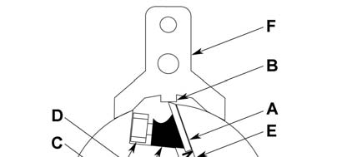
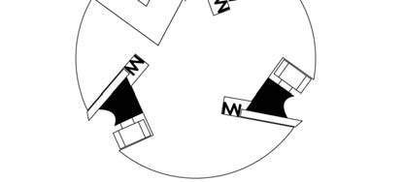
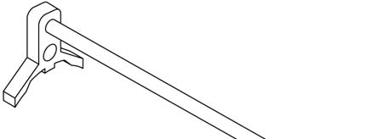
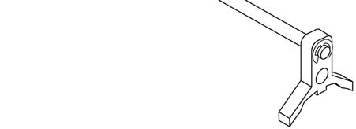

Planer knives are dangerously sharp. Use
extreme caution when inspecting, removing,
sharpening, or replacing knives into the
cutterhead. Failure to comply may cause
serious injury.
3. To check and adjust the knives, use the
provided knife gauge (Fig. 22) and check all
three knives. Press the knife gauge against
the cutterhead as shown in Figure 23.
Referring to Figure 21:
Knives (A) should just contact the bottom of
the center protrusion (B) of the knife gauge

(F).
NOTE: If you are using a dial indicator (not
provided) to adjust the knives, the knives should
protrude 0.059” (1.5mm) from the cutterhead.
Important: Insure that the feet of the knife gauge sit flush against a clean surface of the cutterhead. Make sure that no dust, pitch, or lubrication buildup is present, which can cause errors in the knife blade settings.
4. If an adjustment to one or more of the knives
is necessary, slightly loosen the knife gib (C)
by turning the six gib screws (D) into the gib. Turn the screws just enough to relieve stress in the cutterhead without disturbing the setting of the knives. Do this for all three knives at the same time.
5. With the gauge (F) in place over a knife (A)
continue to loosen the gib screws (D) until
the springs (E) begin raising the knife.
When knife comes into contact with the
center protrusion (B) of the gauge, adjust
the jack screws higher or lower to touch the
bottom of the knife, then snug up the gib by
lightly backing out the six gib screws (D)
against the slot.
Note: At this time, only tighten the knife in the slot just enough to hold knife in position.
Figure 21
6. If additional knives must be reset, repeat
steps 4 and 5 for each knife.
7. After all three knives are set with screws just
snug, back out and tighten the six gib
screws (D, Fig. 21 & Fig. 23) of the first knife
against the slot starting with the end screws,
then the center screws, until the knife is
securely held in the cutterhead. Tighten
remaining two knives in the same manner.
Important: Double check all gib screws for tightness.

Figure 22

14

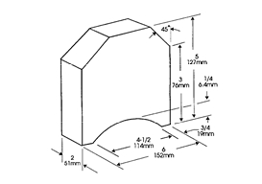
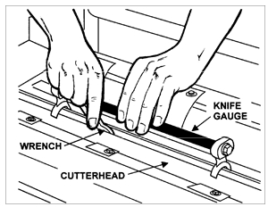

7. Reinsert springs, knives and gib into slot of
the cutterhead. Back out gib screws just
enough to hold the knife in the cutterhead.
8. Place knife gauge (Fig. 23) over knife. Still referring to Figure 21:
9. While holding down on the knife gauge,
loosen all six gib screws (D) by turning them
into the gib (C) until cutting edge of knife
comes into contact with the protrusion of the
gauge (B). Adjust the jack screws higher or
lower to touch the bottom of the knife. Snug
up the gib by slightly backing out the six
locking screws against the slot.

Figure 23
Removing and Replacing Knives

Planer knives are dangerously sharp. Use extreme caution when inspecting, removing, sharpening, or replacing knives into the cutterhead. Failure to comply may cause serious injury.
To remove a knife:
1. Disconnect machine from power source.
2. Remove four screws (A, Fig. 20) from the
upper cover and three from the bottom of
the dust port. Remove the cover/dust port (Fig. 20) as a unit.
The cutterhead assembly can be seen from the opening on top.
Refer to Figure 21:
3. Loosen the gib (C) by turning the six gib
screws (D) into the gib. Remove gib (C),
knife (A) and springs (E).
Note: The inner two springs may pop out when the knife and gib are removed.
4. Remove the remaining two knives in the
same manner.
5. Thoroughly clean the knife slots, gibs,
springs and gib screws. Check the gib
screws; if the threads appear worn or stripped or if the heads are becoming rounded, replace them.
6. Inspect the cutting edge of the knives for
nicks or wire edge. It is recommended that
knives be replaced when they become dull
or damaged. If they are to be reused, refer
to Sharpening Knives in the Maintenance
Section.
Note: At this time only, tighten the knife into
the slot just enough to hold the knife in
position.
10. Replace and reset the other two knives by
repeating steps 3 - 9.
11. After all three knives are set with the screws
just snug, back out and tighten the six
screws (D) against the slot starting with the end screws first and then the center screws until the knife is securely held in the cutterhead. Tighten the remaining two knives in the same manner.
Important: After replacing and checking knives, CHECK AGAIN carefully. Make certain the direction of knives is correct and all eighteen (3 knives x 6 screws) locking screws are tightened securely.
Table Adjustment
To perform the table adjustments described in the next two sections, you will need a straight edge, feeler gauge, and a home made gauge block made of hardwood. Make the gauge block by following the dimensions shown in Fig. 24. Precision adjustments require accuracy when milling the gauge block.

Figure 24

15

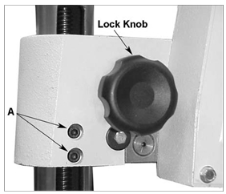
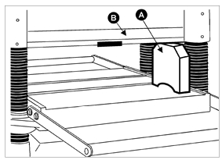

Checking Work Table Parallel to Cutterhead
The worktable is set parallel to the cutterhead at
the factory and no further adjustment should be
needed. If your machine is planing a taper, first
check to see if the knives are set properly in the
cutterhead. Then check to see if the worktable is
set parallel to the cutterhead by proceeding as
follows:
1. Disconnect machine from power source.
2. Turn the handwheel clockwise; raising the
cutterhead assembly high enough to place
the gauge block (A, Fig. 25) on the work table under one end of the head casting (B, Fig. 25).
3. Turn the handwheel to lower the head
assembly until the head casting body barely
touches the gauge block. The blades should not touch the block.
4. Slide the block toward the opposite side of
the head casting. Use a feeler gauge to
measure the width of the gap, if any,
between the top of the block and the bottom
of the cutterhead. Make a note of the gap, if
any.
5. If the block wedges tightly between the table
and the head casting when shifting from one
side to the other, repeat steps 2 through 4,
but start from the opposite end of the head
casting.

Figure 25
If the gap difference from one side to the other is equal to or less than 0.004", no further adjustment is necessary
If the gap difference from one side to the other side is grater than 0.004", but less than 0.016", go to the Adjusting Work Table Parallel to Cutterhead (Fine Adjustment) section.
It the gap difference from one side to the other is
grater than 0.016", the cutterhead assembly
raising chain under the planer base needs to be

adjusted - see the Adjusting Work Table Parallel to Cutterhead (Major Adjustment) section.

Adjusting Work Table Parallel to Cutterhead (Fine Adjustment)
If the gap difference determined in the previous section is greater than 0.004" and less than
0.016", perform the adjustment procedure as follows:
1. Determine which side of the table must be
raised to correct the gap.
2. Locate the two socket head cap screws in
the table casting for each of the columns (A,
Fig. 26). Loosen both sets of screws for
each column on the side you wish to adjust.
3. Push down or pull up the cutterhead
assembly in the desired direction. Hold the
assembly in position and retighten the cap screws.
4. Recheck the table to cutterhead parallelism
again as described in the previous section,
then repeat steps 1 - 3 until the deviation is less than 0.004".

Figure 26

Adjusting Work Table Parallel to
Cutterhead (Major Adjustment)
Refer to Figure 27.
1. Disconnect the machine from power source.
2. On the underside of the base, remove bolt
(A) and loosen bolt (B) which will allow you
to move the idler sprocket assembly (C) far enough to release tension on the chain.
3. Remove chain from the particular sprocket
on the corner of the base that must be
adjusted.

16

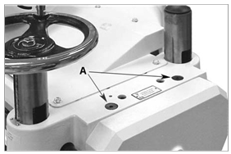
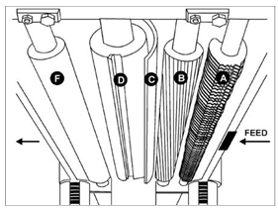
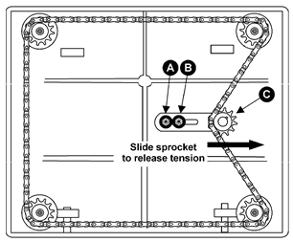

4. Turn the sprocket by hand to bring that
corner into adjustment with the other three
corners.
Note: Turning sprocket clockwise will increase
the distance between the working table and
head casting; counter-clockwise will decrease
the distance. This adjustment is very sensitive -
one revolution of the lead screw equals 0.158”
(4mm) of travel. It should not be necessary to
turn the sprocket more than one or two teeth.
5. When adjustments are correct, replace
chain around the corner sprocket, slide
sprocket (C) back to re-tension chain,

tighten bolt (B) and replace and tighten
bolt (A).
Note: It may be necessary to perform the Fine Adjustment procedure after the major to achieve the best result.

Figure 27
Transmitting Rollers
Figure 28 show the positions of the rollers that are listed below and described in the following sections.
A Anti Kickback Fingers B Infeed Roller
C Chipbreaker
D Cutterhead
F Outfeed Roller
Figure 28

Infeed & Outfeed Roller Spring Tension Adjustment
The infeed roller (B, Fig. 28) and outfeed roller (F, Fig. 28) feed the stock while it is being planed. The infeed and outfeed rollers are under spring tension and this tension must be sufficient to feed the stock uniformly through the planer without slipping but should not be so tight that it causes damage to the board and/or the rubber coating on the outfeed roller. The tension should be equal at both ends of each roller.
To adjust the spring tension of the infeed and
outfeed rollers, turn screws (A, Fig. 29) with a
hex wrench. A clockwise turn increases tension
on the pressure spring (Fig. 30); a
counterclockwise turn decreases tension. Adjust
the screws at the other end of the rollers with the
same number of turns.
Note: The most effective pressure settings are
dependent on the type of lumber being planed.
Experimentation will determine the best settings.

Figure 29

17

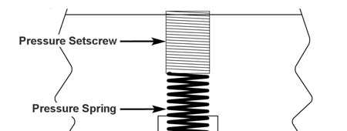
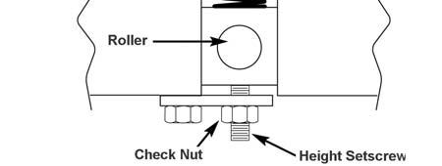


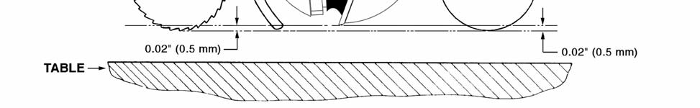

Anti-Kickback
The JWP-16OS Planer provides an anti-
kickback safety feature. The anti-kickback
fingers hang from a rod suspended across the
front of the cutterhead casting (A, Fig. 28) and
help prevent kickback of stock. It is necessary to
inspect them regularly to make sure they hang
freely. Check that they are free of gum and pitch
to insure independent movement and correct
operation.

Figure 30

Figure 31

Checking and Adjusting the Feed Roller Height
The infeed and outfeed rollers propel the lumber through the planer. The rollers also press the lumber flat against the planer table.
The infeed and outfeed rollers are adjusted at the factory and are set at 0.020" below the knife-
edge at bottom dead center (Fig. 31).
Note: Before proceeding with this adjustment, make sure the knives are adjusted properly as outlined in the Knife Adjustment section.
Remove the drive chain cover to access the
roller adjustments on the drive chain side of the
planer.
To check or verify the roller height:
1. Disconnect the machine from the power
source.

2. Turn the handwheel clockwise, raising the
cutterhead assembly high enough to place
the gauge block (J, Fig. 32) on the table
directly underneath the cutterhead
(D, Fig. 32) Using a 0.02” (0.5mm) feeler
gauge (K, Fig. 32) placed on top of the
gauge block, lower the head assembly until
the knife just touches the feeler gauge when
the knife is at its lowest point. Do not move
the working table any further until the infeed
and outfeed rollers are adjusted.

18

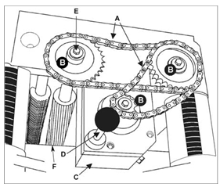
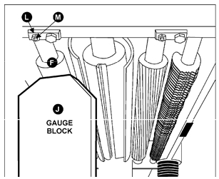
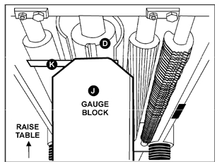

The gearbox is located on the right side of the
planer directly behind the table lock knob (A,
Fig. 35). The gearbox transfers power from the
belt-driven cutterhead to the power feed rollers.
A two-speed transmission, controlled by a
push/pull lever (D), moves the stock through the
planer at either 16 or 20 feet-per minute. The
push/pull lever is set while the machine is
running.

Figure 32
3. Move the gauge block (J, Fig. 33) under one
end of the outfeed roller (F, Fig. 33). The
bottom of the outfeed roller should just touch
the top of the gauge block. If an adjustment
to the outfeed roller is necessary, loosen the
jam nut (L, Fig 33) and turn screw
(M, Fig. 33) until the outfeed roller just
touches the gauge block. Then tighten jam

nut (L, Fig. 33).
4. Slide the gauge block to the other end of the
outfeed roller and repeat the adjustment
described in Step 3.
5. Recheck the settings and repeat steps 1-4 if
necessary.

Figure 33
Gearbox
Referring to Figure 34:
The JWP-16OS Planer is equipped with a spiral,
serrated infeed roller (F) and a solid outfeed
roller. When the feed rollers are engaged, they
turn to feed the stock. The feed rollers are driven
by chains (A) and sprockets (B) in the gearbox.
19
Figure 34
Operation
The JWP-16OS Planer is a powerful
woodworking machine, designed and
constructed for professional-quality applications.

Because of its powerful motor and razor-
sharp knives, the JWP-16OS Planer is
inherently dangerous and should be
operated with considerable caution and
respect. Failure to do so could result in
damage to the machine or severe injury to
the operator or others in the work area.
Overview
There are a number of safety issues that relate directly to the operation of the planer. Keep in mind that these are not all-inclusive. Work situations, wood types, and other variables that differ from shop to shop must be considered in order to operate this planer safely. Always consider safety and common sense first when operating this or other machinery.
1. Always inspect lumber for defects (warping,
cupping, twisting, etc.). Do not use lumber of
questionable quality.
2. Check lumber for nails, staples, imbedded
gravel, etc. before planing.

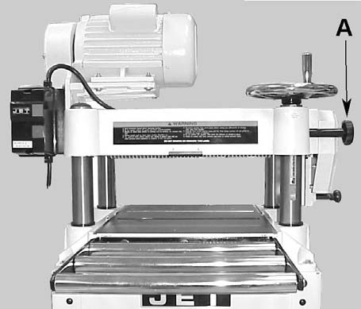
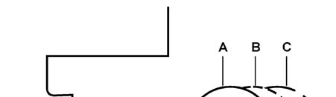
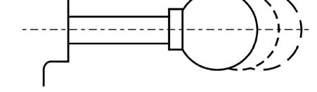

3. Use the full width of the planer. Alternate
between the left, the right and the middle
when feeding lumber into the planer. Your knives will remain sharp much longer.
4. Remove glues, epoxies and other foreign
matter before planing lumber.
5. Never attempt to plane laminates,
particleboards, plastics or other man-made
materials.
6. Plane wood with the grain. Never plane
across the grain.
7. Do not use boards with loose knots, splits,
cross grain or other defects. They can
damage the machine and cause injury.
8. Keep your work area clear.
9. Wood with excessive water content or wood
exposed to rain, ice, or snow will plane
poorly and cause excess wear to the knives and motor. Excessive moisture will also hasten rust and corrosion.
10. Learn as much as possible about planing
procedures. Alternative publications present
more wood specific planing requirements.
Table Locks
Before attempting to adjust table height, loosen the two table lock knobs, one on the right front of the head casting assembly (A, Fig. 35) and the other on the left rear.

Figure 35
After the head assembly height is adjusted, tighten the two black knobs down again.
Power Feed
Referring to Figure 36:
The power feed features two feed rates, 16 FPM
and 20 FPM. When running the machine, the
20

operator can control the feed speed by moving
the feed control knob. Moving the knob toward
the machine produces the 20 FPM feed speed
(A), away from the machine produces 16 FPM
(C) and a center position places the gear box in neutral (B).

Figure 36

Set the feed rate while the planer is running but before feeding lumber into it. DO NOT change speeds after the cutting operation has begun.

If the cut is too large, the planer will slow
down considerably, possibly even stalling
the motor. Turn off the power immediately,
raise the head assembly and remove the
workpiece. Re-adjust the head assembly to
allow a lesser cut and repeat the operation.
Handwheel
Crank the handwheel to raise or lower the table according to the desired workpiece thickness.
Each complete revolution of the handwheel
moves the head assembly by 0.158” (4mm).
Make sure the height scale is properly adjusted.
With the depth-limiting clip installed, you cannot cut full width more than 1/8" in a single pass (3/16" if lumber can fit on either side of the depth limiting clip). While cutting this much material is possible, it is not recommended.
Depth Limiter
The Model JWP-16OS Planer is equipped with a depth limiter - located on the bottom of the cutterhead casting just below the warning label (A, Fig. 37). The depth limiter controls maximum depth of cut to 1/8".

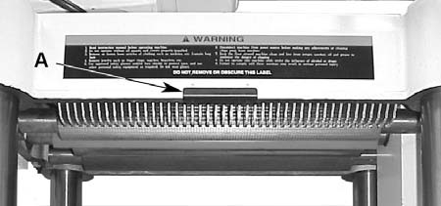

Close-fitting parts, such as the cutterhead slot and gibs, should be cleaned with a cloth or brush and non-flammable solvent, and free from clinging foreign matter.
Remove resin and other accumulations from feed rollers and table with a soft rag and nonflammable solvent.
Periodically check all the chains for proper

Figure 37

To avoid mechanical damage to the planer, do not remove the depth limiter.
Initial Startup
After the assembly and adjustments are complete the planer is ready to be tested.
Turn on the power supply at the main panel.
Press the Start button. Keep your finger on the
Stop button in case of a problem. The planer
should run smoothly with little or no vibration or
rubbing noises. Investigate and correct the
source of any problems before further operation.

DO NOT attempt to investigate or adjust the
planer while it is running. Wait until the
planer is turned off, unplugged and all
working parts have come to a complete
standstill.

Always wear ANSI-approved safety glasses or goggles when operating equipment.
Maintenance
General
Inspect your planer each time before using. Check for the following conditions and repair or replace when necessary.
1. Loose mounting bolts.
2. Worn switch.
3. Worn or damaged cords and plugs.
4. Damaged V-belts.
5. Any other condition that could hamper the
safe operation of this machine.
Buildup of sawdust and other debris can cause your machine to plane inaccurately. Periodic cleaning is not only recommended but also mandatory for accurate planing.
tension and adjust accordingly if required.
Tip: If a foreign object nicks the knives, instead of throwing them away or trying to grind out the deep nick, simply stagger the knives in the head, moving one knife no more than 1/8" to the right and another knife no more than 1/8" to the left. The nick should no longer be noticeable.
The table should be kept clean and free of rust. Some users prefer a paste wax on exposed steel and cast iron surfaces. The wax provides a layer of protection as well as reducing friction between lumber and the table making cuts faster and smoother. Avoid any wax that contains silicone or other synthetic ingredients. These materials can find their way into lumber and can make staining and finishing difficult.
Another option is talcum powder applied with a blackboard eraser rubbed in vigorously once a week; this will fill casting pores and form a moisture barrier. This method provides a tabletop that is slick and allows rust rings to be easily wiped from the surface. Another important fact is that talcum powder will not stain wood or mar finishes as wax pickup does.
Sharpening Knives
It is recommended that knives be replaced they become dull or damaged.
If knives are to be reused, it is recommended
that they be sharpened by a professional knife
sharpener. Improperly sharpened knives can
cause a number of defects to lumber and put
unnecessary load on the motor and drive
systems.
If you must sharpen the knives yourself, please take note of the following information:
Primary Grinding Angle - 40 degrees
Secondary Grinding Angle - 42 degrees

21





The grinding angle has been determined by the
factory to be the best compromise for planing a
wide variety of wood types. In most cases, that
angle will produce excellent results. If you
choose to change the angle of your bevel, be
sure to consult with a trained sharpener or with a
reference book before you commit to changing
the angle of bevel.

Figure 38

22
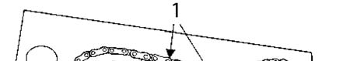
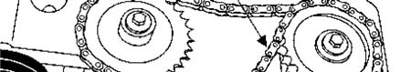
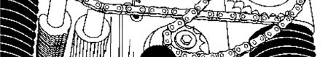
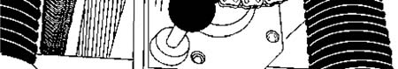
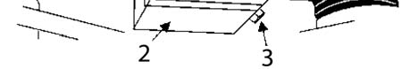
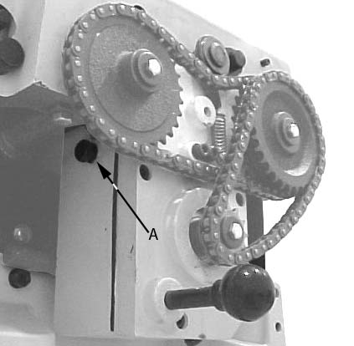

Lubrication

The bearings on the cutterhead are factory
lubricated and sealed for life - no lubrication
required.
Gearbox - The oil in the gearbox must be drained and replaced after the first 20 hours of operation. (See the Lubrication Table).
Inspect levels periodically and change yearly. Replace gear oil more frequently under heavy use. Fill until the oil reaches the top of the filler plug port for correct oil level.

Figure 39
To replace the gearbox lubricant:
1. Remove the drain plug (3. Fig. 39), and filler
cap (A, Fig. 40). Drain dirty oil thoroughly.
2. Tighten the drain plug (3, Fig. 39).
3. Fill with clean lubricant through hole
(A, Fig. 40).
Tighten filler cap (A, Fig. 40).

Figure 40

No Fig Position Interval Suitable Types of Lubricant

1 39 Drive Chain Inspect and lubricate monthly Grease

2 39 Gear Box

When operated more than 2,500 hours

HD-100, Mobil Gear 627, Shell Omala 100, ESSO Spartan EP-100

3 41 Lead Screw Inspect and lubricate Monthly Grease

4 41 Column Inspect and lubricate weekly SAE-30

5 42 Table Chain

6 43 Feed Rollers

Inspect monthly - lubricate when needed

Inspect and lubricate daily before startup

Grease or good quality bicycle chain lubricant

SAE-30

Lubrication Table

23

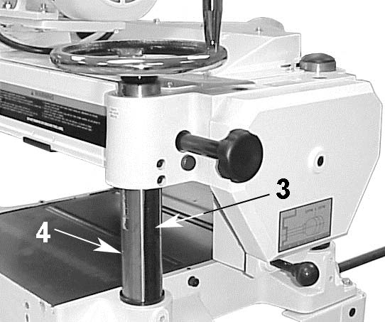
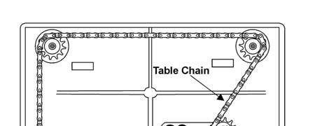
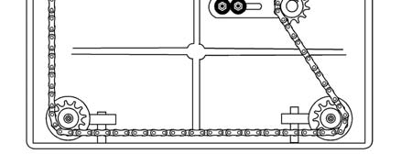
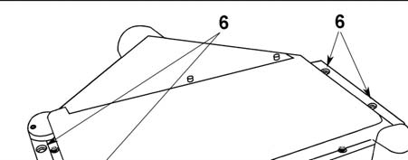
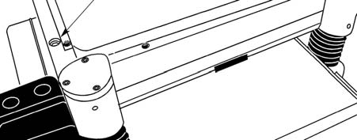

Figure 43
Figure 41

Figure 42

Optional Accessories
708814 Knives (set of 3)
708119 Universal Mobil Base

24

Troubleshooting
Performance Troubleshooting
Problem Possible Cause Solution
Snipe Table rollers not set properly. Adjust rollers to proper height

Inadequate support of long
Note: Snipe can boards.
be minimized but
not eliminated Uneven feed roller pressure front
to back.
Support long boards with extension rollers.

Adjust feed roller tension

Dull knives. Sharpen knives.

Lumber not butted properly. Butt end to end each piece of stock as they

pass through.

Fuzzy Grain Planing wood with a high Remove high moisture content from wood by

moisture content. drying.

Dull knives. Sharpen or replace.

Torn Grain Too heavy a cut. Adjust proper depth of cut

Knives cutting against grain. Cut along the grain.

Dull knives. Sharpen knives.

Rough/Raised Dull knives. Sharpen knives.

Grain

Too heavy a cut. Adjust proper depth.

Moisture content too high. Remove high moisture content from wood by

drying.

Rounded, glossy Dull knives. Sharpen or replace knives.

surface

Feed speed too slow. Increase speed.

Cutting depth too shallow. Increase depth.

Poor feeding of Inadequate feed roller pressure. Adjust feed roller tension. If proper tension

lumber. cannot be achieve, replace feed rollers

Planer bed rough or dirty. Clean pitch and residue, and wax planer table.

Transmission v-belt slipping. Tighten transmission v-belt.

Surface of feed rollers clogged. Clear pitch and residue out of teeth.

Uneven depth of Knife projection. Adjust knife projection.

cut side to side.

Cutterhead not level with bed. Level bed.

Board thickness Depth of cut scale incorrect. Adjust depth of cut scale.
does not match
depth of cut
scale.

25

Mechanical Troubleshooting
Problem Possible Cause Solution
Chain jumping. Inadequate tension. Adjust chain tension.
Sprockets misaligned. Align sprockets
Sprockets worn. Replace sprockets.
Machine will No incoming power. Verify unit is connected to power
not start/ restart
or repeatedly Overload automatic When planer overloads on the circuit breaker built into
trips circuit reset has not reset the motor starter, it takes time for the machine to cool
breaker or down before restart. Allow unit to adequately cool before
blows fuses. attempting restart. If problem persists, check amp setting
on the motor starter inside the electrical box.

Planer frequently trips.
One cause of overloading trips, which are not electrical in
nature, is too heavy a cut. The solution is to take a lighter
cut. If too deep a cut is not the problem, then check the
amp setting on the overload relay. Match the full load
amps on the motor as noted on the motor plate. If the
amp setting is correct then there is probably a loose
electrical lead. Check amp setting on motor starter.

Building circuit breaker Verify that planer is on a circuit of correct size. If circuit

trips or fuse blows. size is correct, there is probably a loose electrical lead.

Check amp setting on motor starter.

Loose electrical Go through all the electrical on the planer including motor

connections. connections, verifying the tightness of each. Look for any
signs of electrical arcing which is a sure indicator of loose connections or circuit overload.
Motor starter failure. Examine motor starter for burned or failed components. If
damage is found, replace motor starter. If motor starter
looks okay but is still suspect, you have two options: have a qualified electrician test the motor starter for function, or purchase a new starter and establish if that was the
problem on changeout
Motor starter failure. If you have access to a voltmeter, you can separate a
starter failure from a motor failure by first, verifying
incoming voltage at 220+/-20 and second, checking the
voltage between starter and motor at 220+/-20. If
incoming voltage is incorrect, you have a power supply
problem. If voltage between starter and motor is
incorrect, you have a starter problem. If voltage between
starter and motor is correct, you have a motor problem.
Motor failure. If electric motor is suspect, you have two options: Have a
qualified electrician test the motor for function or remove the motor and take it to a quality electric motor repair shop and have it tested.
Miswiring of the unit. Double check to confirm all electrical connections are
correct and properly tight. The electrical connections
other than the motor are pre-assembled and tested at the
factory. Therefore, the motor connections should be
double checked as the highest probability for error. If
problems persist, double-check the factory wiring.
26

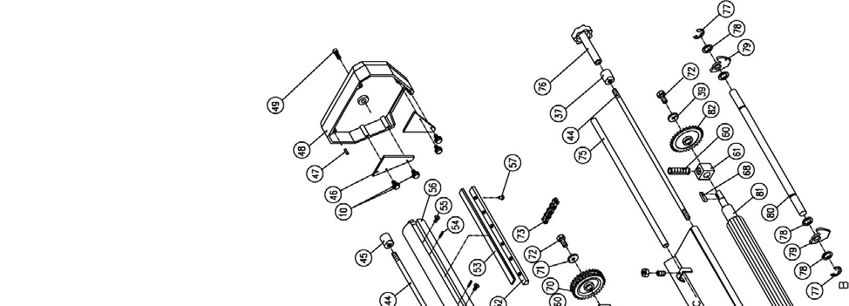
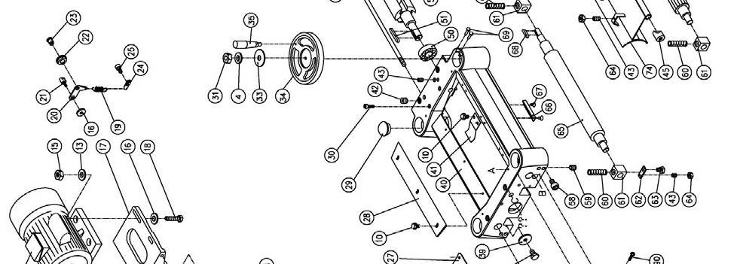
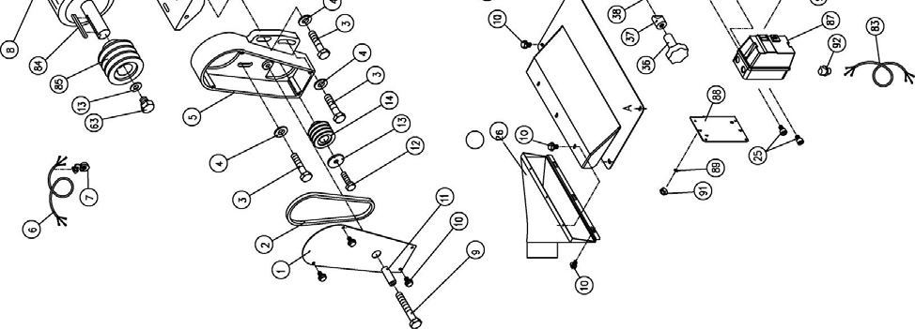

Parts List for the JWP-16OS Planer
Head Assembly

27

Head Assembly Parts List

Index No. Part No. Description Size Quantity
1 JWP16OS-101 Pulley Guard 1
2 JWP16OS-102 V-belt M27 3
3 TS-1491041 Hex Cap Screw M10×30L 3
4 TS-1550071 Flat Washer M10 4
5 JWP16OS-105 Pulley Cover 1
6 JWP16OS-106 Motor Cable 1
7 JWP16OS-107 Strain Relief 1
8 JWP16OS-108 Motor 1
9 JWP16OS-109 Hex Cap Screw M10×80L 1
10 JWP16OS-110 Hex Flange Screw M6×12L 27
11 JWP16OS-111 Spacer 1
12 TS-1490041 Hex Cap Screw M8×25L 1
13 TS-1550061 Flat Washer M8 9
14 JWP15H-014 Machine Pulley 1
15 TS-1540061 Hex Nut M8 12
17 JWP16OS-117 Motor Mount 1
18 TS-1490081 Hex Cap Screw M8×45L 4
19 PA-C61 Spring 1
20 PA-C58 Bracket 1
21 PA-C59 Shaft 1
22 PA-C57 Idle Pulley 1
23 PA-C56 Shaft 1
24 PA-C60 Hanger 1
25 TS-1503031 Socket Head Cap Screw M6×12L 3
26 JWP16OS-126 Collector Hood 1
27 JWP16OS-127 Upper Cover 1
28 JWP15H-040 Deflector Plate 1
29 JWP16OS-129 Cap 3
30 TS-1504101 Socket Head Cap Screw M8×50L 4
31 TS-1540072 Hex Nut M10-1.25M 4
33 JWP16OS-133 Label, Direction 1
34 JWP16OS-134 Handwheel 1
35 JWP15H-060 Handle 1
36 JWP15H-109 Knob 1
37 JWP15H-108 Lock Bushing 2
38 TS-1482021 Hex Cap Screw M6×12L 4
39 TS-1550041 Flat Washer M6 6
40 JWP16OS-140 Head Casting 1
41 JWP15H-036 Plate Spring 3
42 JWP15H-021 Socket Set Screw M22-1.5P×20L 4
43 TS-1523051 Socket Set Screw M6×16L 4
44 JWP16OS-144 Shaft 2
45 JWP15H-106 Lock Bushing 2
46 PF-C22 Plate 2
47 JWP15H-062 Spring Pin 2
48 JWP15H-061 Cover 1
49 TS-1504091 Socket Head Cap Screw M8×45L 1
50 JWP16OS-150 Ball Bearing 6205-2NSE 1
51 JWP16OS-151 Key 8×8×40 1
52 JWP16OS-152 Knife Bar 3
53 708814 Knives (Set of 3) 1
54 JWP16OS-154 Spring 6
55 TS-1513021 Socket Head Flat Screw M5×12L 6
56 JWP16OS-156 Cutterhead 1

28

Head Assembly Parts List

Index No. Part No. Description Size Quantity
57 JWP15H-007 Screw 18
58 TS-1503041 Socket Head Cap Screw M6×16L 8
59 TS-1524031 Socket Set Screw M8×12L 1
60 JWP15H-020 Spring 4
61 JWP208-019 Bushing 4
62 JWP15H-022 Plate 4
63 TS-1490031 Hex Cap Screw M8×20L 5
64 TS-1540041 Hex Nut M6 6
65 JWP16OS-165 Outfeed Roller 1
66 JWP15H-046 Limiter Plate 1
67 TS-1534041 Machine Screw, Flat Head Phillips M5-10L 2
68 JWP15H-026 Key 5×5×22 2
69 JWP16OS-169 Rivet 2
70 JWP15H-031 Sprocket 4
72 TS-1482031 Hex Cap Screw M6×16L 2
73 JWP15H-073 Chain 06B×63P 1
74 JWP16OS-174 Chip Bracket 1
75 JWP16OS-175 Shaft 1
76 JWP16OS-176 Knob 1
77 JWP15H-045 Retaining Ring ETW-15 2
78 JWP15H-042 Collar 45
79 JWP15H-041 Anti-Kick Finger 44
80 JWP16OS-180 Shaft 1
81 JWP16OS-181 Infeed Roller 1
82 JWP15H-027 Sprocket 1
83 JWP16OS-183 Power Cord 1
84 JWP16OS-184 Key 5×5×30 1
85 JWP15H-017 Motor Pulley 1
87 JWP16OS-187A Switch 1
88 JWP15H-076A Switch Plate 1
89 JWP16OS-189 Tooth Washer 2
90 JWP16OS-190 Screw 3/16-24 x 1-3/4 2
91 JWP16OS-191 Hex Nut 3/16-24 2
92 JWP16OS-192 Strain Relief 2

29

Base Assembly

Base Assembly Parts List

Index No. Part No. Description Size Quantity
1 JWP16OS-201 Lifting Handle 4
2 JWP15H-207 Nut Fixture 4
3 JWP16OS-203 Leadscrew 3
4 JWP16OS-204 Column 3
5 TS-1523041 Socket Set Screw M6×12L 4
6 JWP15H-203 Column 4
7 JWP16OS-207 Base 1
8 TS-1525021 Socket Set Screw M10×12L 8
9 JWP16OS-209 Roller 2
10 BB-608Z Ball Bearing 4
11 JWP15H-104 Eccentric Shaft 4
12 JWP15H-221 Bracket 1
13 JWP15H-222 Shaft 1
14 JWP15H-223 Sprocket 1
15 JWP15H-224 Retaining Ring STW-15 1
16 JWP16OS-216 Chain 41×148P 1
17 TS-1550061 Flat Washer M8 18

30

Base Assembly Parts List

Index No. Part No. Description Size Quantity
18 TS-1490041 Hex Cap Screw M8×25L 2
19 BB-6202ZZ Ball Bearing 6202ZZ 4
20 JWP15H-214 Retaining Ring RTW-35 4
21 JWP15H-216 Sprocket 4
22 TS-0680041 Flat Washer 3/8 4
23 TS-1540072 Nut M10-1.25P 4
24 JWP15H-209 Retaining Ring RTW-38 1
25 JWP15H-208 Bushing 1
26 JWP16OS-226 Key 4×4×20 1
27 JWP16OS-227 Leadscrew 1
28 JWP16OS-228 Scale 1
29 TS-1531012 Machine Screw, Pan Head Phillips M3×6L 2
30 JWP16OS-230 Column 1
31 TS-1490031 Hex Cap Screw M8×20L 6
32 TS-1524031 Socket Set Screw M8×12L 6
33 TS-1490051 Hex Cap Screw M8×30L 4
35 JWP16OS-235 E-ring ETW-10 4
36 JWP15H-111 Roller Frame 2
37 TS-1482021 Hex Cap Screw M6×12L 12
38 TS-1550041 Flat Washer M6 12
39 JWP15H-113 Roller Liner 12
40 JWP15H-114 Roller Shaft 6
41 JWP15H-112 Roller 6

31
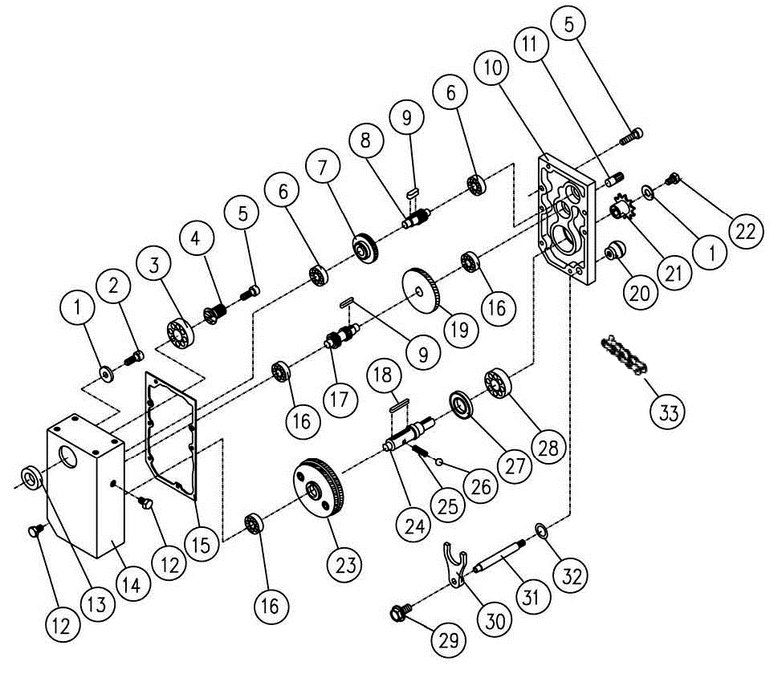

Gear Box Assembly

32

Gear Box Assembly Parts List

Index No. Part No. Description Size Quantity
1 TS-1550041 Flat Washer M6 2
2 TS-1503031 Socket Head Cap Screw M6×12L 1
3 BB-6204ZZ Ball Bearing 6204ZZ 1
4 JWP15H-304 Gear 1
5 TS-1503061 Cap Screw M6x25L 6
6 BB-6201 Ball Bearing 6201 1
7 JWP15H-309 Gear 47T 1
8 JWP15H-310 Gear 18T 1
9 JWP15H-313 Key 5x5x10 2
10 JWP15H-337 Cover 1
11 JWP15H-335 Pin 2
12 JWP15H-339 Oil Plug 2
13 OS-28408 Oil Seal TC28x40x8 1
14 JWP15H-301 Gear Box 1
15 JWP15H-336 Gasket 1
16 BB-6201Z Ball Bearing 6201Z 3
17 JWP15H-314 Shaft 1
18 JWP15H-320 Key 6x6x40 1
19 JWP15H-312 Gear 71T 1
20 JWP15H-334 Knob 1
21 JWP15H-325 Sprocket 12T 1
22 TS-1482031 Hex Cap Screw M6x16L 1
23 JWP15H-318 Gear Assembly 96/92T 1
24 JWP15H-323 Shaft 1
25 JWP15H-322 Spring 1
26 JWP15H-321 Ball 1
27 OS-25476 Oil Seal 1
28 BB-6204Z Ball Bearing 6204Z 1
29 JWP16OS-329 Hex Flange Screw M6x12L 1
30 JWP15H-329 Clutch 1
31 JWP15H-330 Handle 1
32 JWP15H-333 Oil Seal 1
33 JWP15H-327 Chain 1

33
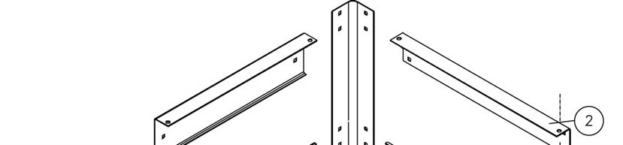
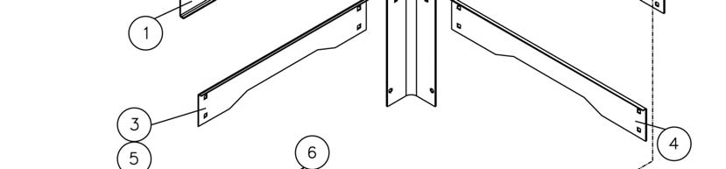
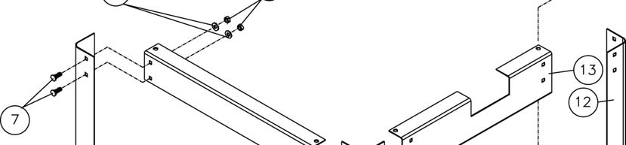
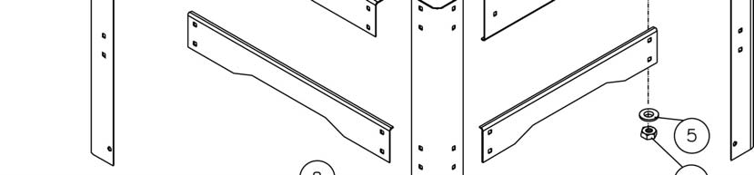


Stand Assembly

Stand Assembly Parts List

Index No. Part No. Description Size Quantity
1 JWP16OS-401 Upper Side Brace (L) 1
2 JWP16OS-402 Upper Front Brace 2
3 JWP16OS-403 Down Side Brace (R) 2
4 JWP16OS-404 Down Front Brace 2
5 TS-1550061 Flat Washer M8 48
6 TS-0561021 Hex Nut 5/16”-18 32
7 JWP16OS-407 Carriage Bolt 5/16”-18×14L 32
8 TS-1540061 Hex Nut M8 12
9 TS-1515021 Socket Head Flat Screw M8x20L 8
10 JWP16OS-410 Foot 4
12 JWP16OS-412 Leg 4
13 JWP16OS-413 Upper Side Brace (R) 1

34

Electrical Schematic for JWP-16OS Planer

A1 A

1L1 3L2 5L3 13NO

2T1 4T2 6T3 14NO

A2

R R
O

ManAuto
98 97 96 95

35
17



WALTER MEIER (Manufacturing) Inc.
427 New Sanford Road
LaVergne, TN 37086
Phone: 800-274-6848
www.waltermeier.com

36

